**Week 4 Homework Submission File**

**Linux Systems Administration**

**Step 1: Ensure/Double Check Permissions on Sensitive Files**

1. Permissions on /etc/shadow should allow only root read and write access.
   * Command to inspect permissions: **ls -l /etc/shadow**
   * Command to set permissions (if needed): **sudo chmod 600 /etc/shadow**
2. Permissions on /etc/gshadow should allow only root read and write access.
   * Command to inspect permissions: **ls -l /etc/gshadow**
   * Command to set permissions (if needed): **sudo chmod 600 /etc/shadow**
3. Permissions on /etc/group should allow root read and write access, and allow everyone else read access only.
   * Command to inspect permissions: **ls -l /etc/group**
   * Command to set permissions (if needed): **sudo chmodd 644 /etc/group**
4. Permissions on /etc/passwd should allow root read and write access, and allow everyone else read access only.
   * Command to inspect permissions: **ls -l /etc/passwd**
   * Command to set permissions (if needed): **sudo chmod 644 /etc/passwd**

**Step 2: Create User Accounts**

1. Add user accounts for sam, joe, amy, sara, and admin.
   * Command to add each user account (include all five users):
     1. **sudo adduser sam**
     2. **sudo adduser joe**
     3. **sudo adduser am**
     4. **sudo adduser sara**
     5. **sudo adduser admin**
2. Ensure that only the admin has general sudo access.
   * Command to add admin to the sudo group: **sudo usermod -aG sudo admin**

**Step 3: Create User Group and Collaborative Folder**

1. Add an engineers group to the system.
   * Command to add group: **sudo addgroup engineers**
2. Add users sam, joe, amy, and sara to the managed group.
   * Command to add users to engineers group (include all four users): **sudo usermod -aG engineers joe | sudo usermod -aG engineers sam | sudo usermod -aG engineers amy | sudo usermod -aG engineers sara**
3. Create a shared folder for this group at /home/engineers.
   * Command to create the shared folder: **sudo mkdir /home/engineers**
4. Change ownership on the new engineers' shared folder to the engineers group.
   * Command to change ownership of engineer's shared folder to engineer group: **sudo chown :engineers /home/engineers**

**Step 4: Lynis Auditing**

1. Command to install Lynis: **apt install lynis**
2. Command to see documentation and instructions: **man lynis OR sudo lynis show help**
3. Command to run an audit: **sudo lynis audit system**
4. Provide a report from the Lynis output on what can be done to harden the system.
   * 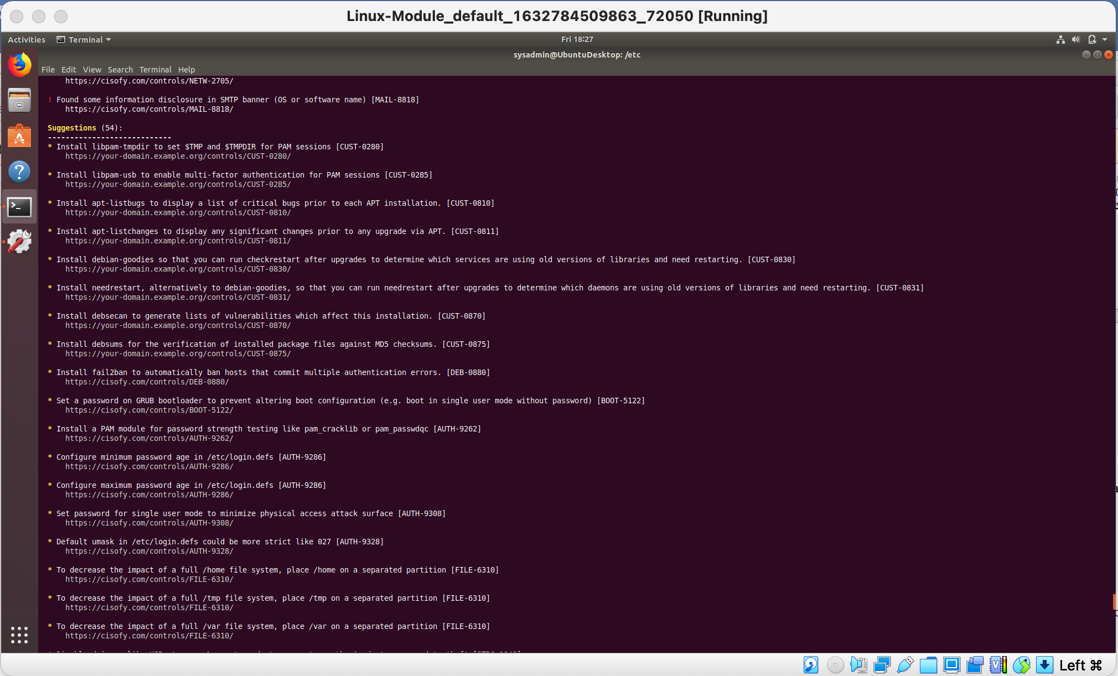Screenshot of report output:

**Bonus**

1. Command to install chkrootkit: ﻿**sudo apt install chkrootkit**
2. Command to see documentation and instructions: **man chkrootkit OR sudo chkrootkit show help**
3. Command to run expert mode: **chkrootkit -x**
4. Provide a report from the chrootkit output on what can be done to harden the system.
   * Screenshot of end of sample output:

